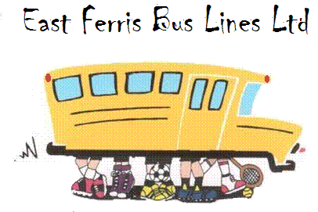

We are currently hiring bus & van drivers to become a part of our transportation team. If you like to drive and would enjoy being a part of our students’ day, we are looking for you. We will train qualified applicants and assist them in getting the required license.

For more information please call Claude at 752-1326 or visit our website at www.eastferrisbus.ca

